PA B2-3: LISTS
TOPIC
B2
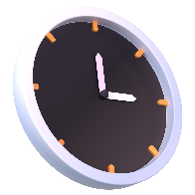
TIME TO COMPLETE: 1 HOUR

Write your responses to parts 2 and 4 in a word document. Make sure to include your name and the programming assignment number. Your code can be uploaded alongside the accompanying word document.

PART 1: PROBLEM STATEMENT
Matrix calculations are used extensively in Machine Learning for computer science. I need your help to write a program that will calculate a dot product between two of these matrices.
When you’re calculating the dot product, you’ll need to ensure that
- The width of matrix A matches the height of matrix B.
A dot product is calculated by multiplying each number from row 1 of matrix A with the respective number from column 1 of matrix B, since the rows of matrix A and columns of matrix B should be the same length, and adding those results together, then moving on to row 2 and column 2 respectively. Below is an image that demonstrates how it works.
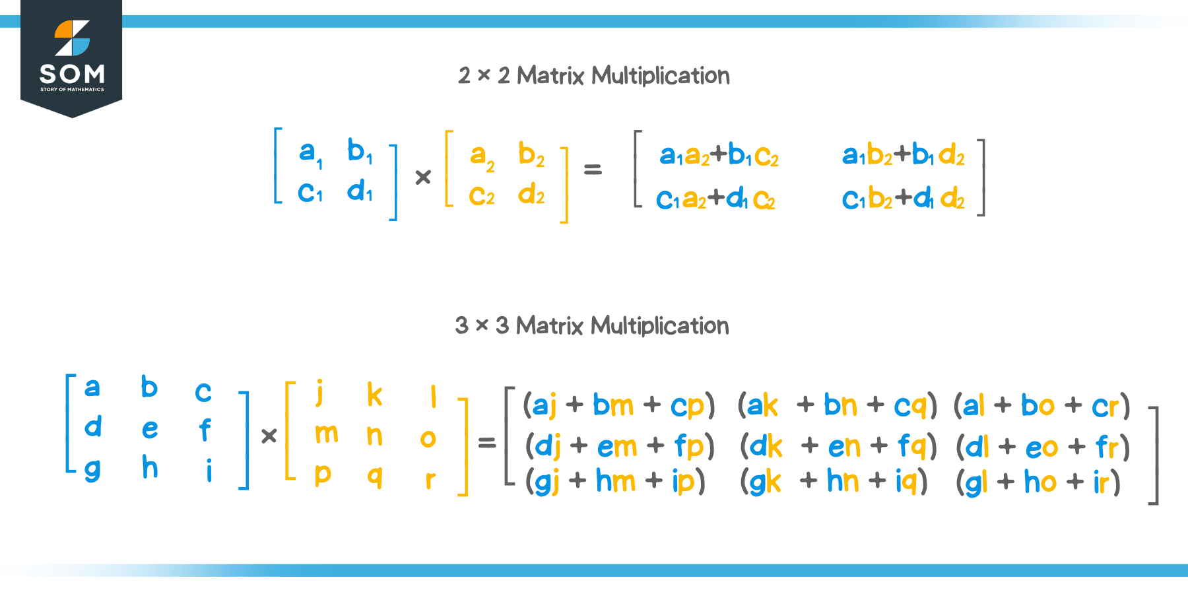
The output matrix will have the height of matrix A and the width of matrix B.
I need you to write a program that will take input for the size of two matricies (2D lists), allow the user to fill them in, and then calculate and output the dot product of the two matrices, ensuring that the sizing fits the constraints.
You will likely need to do some independent research to understand matrices a bit more.
Ensure that output is formatted in a grid and not in a line. See the example below.

PART 2: BRAINSTORMING THE ALGORITHM
- How will you get input from the user detailing the size of the matrices? How will this input be used? [5]

- How will you allow the users to populate the entries in a matrix? Specify which structures and why they work. [10]

- What will be the algorithm to perform the multiplication and storing it into a new matrix? [10]
PART 3: WRITE THE PROGRAM
Write your code in a .py file using no dependencies (using other libraries or programs). Feel free to use the IDE of your preference, but ensure you only upload the .py file (alongside the answers to the questions in this document).
Your program will need to take input for as many words as the user would like to enter. Ensure that your submission adheres to the FIVE LAWS OF CODECRAFT.
Example output is provided below.

Upload the .py file with your program to ManageBac. [5]
Ensure that your program gets input for each cell of the matrix from the user [5]
Ensure the program will not run with invalid matrix dimensions [5]
Ensure that your program returns correct values for matrix multiplication [20]
Ensure that your output is formatted properly across multiple lines in the output window [5]
Ensure that your program can multiply matrices of different dimensions [5]

PART 4: REFLECTION
Answer the following questions in the "Programming Assignment Documentation Template" that can be found in ManageBac.
- Did your final project match up with your idea from the brainstorming phase? If not, what changed? [5]

- Are there any known bugs in your program that you could not address? [5]

- What was the most complex part about programming this matrix multiplication? How did you understand how to create the program? [5]

- List the values that you tested the program with and explain why you chose those inputs. You should use at least 3 sets of input values. [10]

- List any sources used in the creation of your program and how you used them, as well as any sources used to further understand matrix multiplication. [5]

